Міністерство освіти і науки України

Національний технічний університет України

«Київський Політехнічний Інститут імені Ігоря Сікорського»

Факультет прикладної математики

Кафедра «Спеціалізованих комп’ютерних систем»

Лабораторна робота №1

З дисципліни «Комп’ютерна схемотехніка» :

«Проектування комбінаційних схем»

Виконав:

студент III курсу,

група КВ-41

Яковенко Максим

Перевірив:

_____________________

Київ-2016

***Постановка задачі***

Мета роботи ­– опанувати методику проектування комбінаційних схем у заданому елементному базисі та дослідження їх характеристик.

***Вхідні данні***

Варіант: 21;

|  |  |  |  |  |  |  |  |  |  |  |  |  |  |  |  |  |  |  |  |  |  |  |  |  |  |  |  |  |  |  |  |  |  |  |  |  |  |  |  |  |  |  |  |  |  |  |  |  |  |  |  |  |  |  |  |  |  |  |  |  |  |  |  |  |  |  |  |  |  |  |  |  |  |  |  |  |  |  |  |  |  |  |  |  |  |  |  |  |  |  |  |  |  |  |  |  |  |  |  |  |  |  |  |  |  |  |  |  |  |  |  |  |  |  |  |  |  |  |  |  |  |  |  |  |  |  |  |  |  |  |  |  |  |  |  |  |  |  |  |  |  |  |  |  |  |  |  |  |  |  |  |  |  |  |  |  |  |  |  |  |  |  |  |  |  |  |  |  |  |  |  |  |  |  |  |  |  |  |  |  |  |  |  |  |  |  |  |  |  |  |  |  |  |  |  |  |  |  |  |  |  |  |  |  |  |  |  |  |  |  |  |  |  |  |  |  |  |  |  |  |  |  |  |  |  |  |  |  |  |  |  |
| --- | --- | --- | --- | --- | --- | --- | --- | --- | --- | --- | --- | --- | --- | --- | --- | --- | --- | --- | --- | --- | --- | --- | --- | --- | --- | --- | --- | --- | --- | --- | --- | --- | --- | --- | --- | --- | --- | --- | --- | --- | --- | --- | --- | --- | --- | --- | --- | --- | --- | --- | --- | --- | --- | --- | --- | --- | --- | --- | --- | --- | --- | --- | --- | --- | --- | --- | --- | --- | --- | --- | --- | --- | --- | --- | --- | --- | --- | --- | --- | --- | --- | --- | --- | --- | --- | --- | --- | --- | --- | --- | --- | --- | --- | --- | --- | --- | --- | --- | --- | --- | --- | --- | --- | --- | --- | --- | --- | --- | --- | --- | --- | --- | --- | --- | --- | --- | --- | --- | --- | --- | --- | --- | --- | --- | --- | --- | --- | --- | --- | --- | --- | --- | --- | --- | --- | --- | --- | --- | --- | --- | --- | --- | --- | --- | --- | --- | --- | --- | --- | --- | --- | --- | --- | --- | --- | --- | --- | --- | --- | --- | --- | --- | --- | --- | --- | --- | --- | --- | --- | --- | --- | --- | --- | --- | --- | --- | --- | --- | --- | --- | --- | --- | --- | --- | --- | --- | --- | --- | --- | --- | --- | --- | --- | --- | --- | --- | --- | --- | --- | --- | --- | --- | --- | --- | --- | --- | --- | --- | --- | --- | --- | --- | --- | --- | --- | --- | --- | --- | --- | --- | --- | --- | --- | --- | --- | --- | --- | --- | --- | --- | --- |
| Таблиця 1.2   |  |  |  |  |  | | --- | --- | --- | --- | --- | | X1 | X2 | X3 | X4 | Y | | 0 | 0 | 0 | 0 | 0 | | 0 | 0 | 0 | 1 | 1 | | 0 | 0 | 1 | 0 | 0 | | 0 | 0 | 1 | 1 | 1 | | 0 | 1 | 0 | 0 | 0 | | 0 | 1 | 0 | 1 | 1 | | 0 | 1 | 1 | 0 | 0 | | 0 | 1 | 1 | 1 | 1 | | 1 | 0 | 0 | 0 | 1 | | 1 | 0 | 0 | 1 | 0 | | 1 | 0 | 1 | 0 | 0 | | 1 | 0 | 1 | 1 | 1 | | 1 | 1 | 0 | 0 | 1 | | 1 | 1 | 0 | 1 | 0 | | 1 | 1 | 1 | 0 | 1 | | 1 | 1 | 1 | 1 | 0 | | Таблиця 1.3   |  |  |  |  |  |  |  |  |  | | --- | --- | --- | --- | --- | --- | --- | --- | --- | | Входи | | | | Виходи | | | | | | X1 | X2 | X3 | X4 | Z1 | Z2 | Z3 | Z4 | | 0 | 0 | 0 | 0 | 0 | 0 | 1 | 0 | | 0 | 0 | 0 | 1 | 0 | 1 | 0 | 1 | | 0 | 0 | 1 | 0 | 0 | 1 | 0 | 1 | | 0 | 0 | 1 | 1 | 0 | 1 | 1 | 0 | | 0 | 1 | 0 | 0 | 0 | 1 | 1 | 1 | | 0 | 1 | 0 | 1 | 1 | 0 | 0 | 0 | | 0 | 1 | 1 | 0 | 1 | 0 | 0 | 0 | | 0 | 1 | 1 | 1 | 1 | 0 | 1 | 1 | | 1 | 0 | 0 | 0 | 1 | 0 | 1 | 0 | | 1 | 0 | 0 | 1 | 1 | 1 | 0 | 1 | | 1 | 0 | 1 | 0 | 1 | 1 | 0 | 1 | | 1 | 0 | 1 | 1 | 1 | 1 | 1 | 0 | | 1 | 1 | 0 | 0 | 1 | 1 | 1 | 0 | | 1 | 1 | 0 | 1 | 0 | 0 | 0 | 0 | | 1 | 1 | 1 | 0 | 0 | 0 | 0 | 1 | | 1 | 1 | 1 | 1 | 0 | 0 | 1 | 0 | |

Таблиця 1.4

|  |  |  |  |
| --- | --- | --- | --- |
|  | Тип елементів | Кількість елементів у корпусі мікросхеми | Час затримки сигналу *t*, нс |
| 101 | 2І-НЕ  2АБО | 4  4 | 20  22 |

Канонічні форми

|  |  |  |  |  |  |
| --- | --- | --- | --- | --- | --- |
|  | X1 | |  |  |  |
| X2 | 1 | 0 | 0 | 1 |  |
| 1 | 0 | 1 | 0 | X3 | |
|  | 0 | 1 | 1 | 0 |
|  | 0 | 1 | 1 | 0 |  |
|  |  | X4 | |  |  |

$Y=\overline{x1}x4∪x1x2\overline{x4}∪x1\overline{x3}\overline{x4}∪\overline{x2}x3x4$

***Операторні форми***

Згідно таблиці 1.4 можливо реалізувати форми: АБО/І-НЕ, І-НЕ / І-НЕ.

Операторна форма АБО/І-НЕ:

$$Y=\overline{\left(x1∪\overline{x4}\right)\left(\overline{x1}∪\overline{x2}∪x4\right)\left(\overline{x1}∪x3∪x4\right)\left(x2∪\overline{x3}∪\overline{x4}\right)}=\overline{\left(x1∪\overline{x4}\right)\left(\overline{(x1}∪\overline{x2})∪x4\right)\left((\overline{x1}∪x3)∪x4\right)\left(x2∪(\overline{x3}∪\overline{x4)}\right)}$$

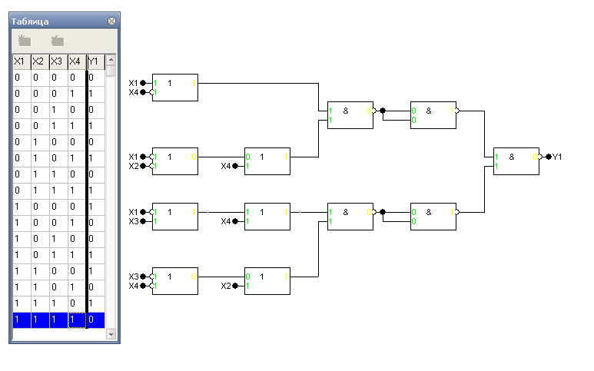

N= $\left]\frac{7}{4}\right[*\frac{14}{14}+\left]\frac{5}{4}\right[*\frac{14}{14}=2+2=4$

T=2AБО+3І-НЕ=2*22+3*20=104  
Операторна форма І-НЕ / І-НЕ:

$$Y=\overline{\overline{\left(\overline{x1}x4\right)}\&\overline{\left(x1x2\overline{x4}\right)}\&\overline{\left(x1\overline{x3}\overline{x4}\right)}\&\overline{(\overline{x2}x3x4)}}=\overline{\overline{\left(\overline{x1}x4\right)}\&\overline{\left(\overline{\overline{\left(x1x2\right)}}\overline{\overline{\overline{x4}}}\right)}\&\overline{\left(\overline{\overline{x1}}\overline{\overline{\left(\overline{x3}\overline{x4}\right)}}\right)}\&\overline{(\overline{\overline{\overline{x2}}}\overline{\overline{(x3x4)}})}}$$

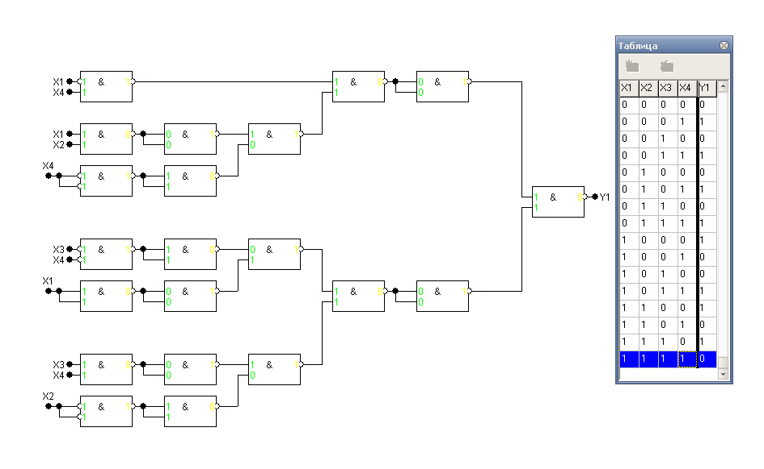

N= $\left]\frac{21}{4}\right[*\frac{14}{14}=6$

T=6І-НЕ=6*20=120

***Побудова функції на мультиплексорі***

**Розклад за :**



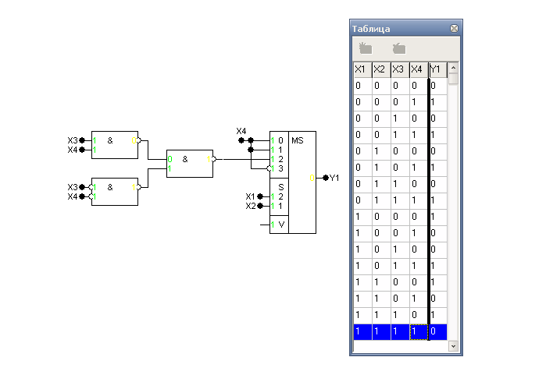

N= $\left]\frac{3}{4}\right[*\frac{14}{14}+\left]\frac{1}{2}\right[*\frac{16}{14}=1+1.14=2.14$ 
**Pозклад за :**



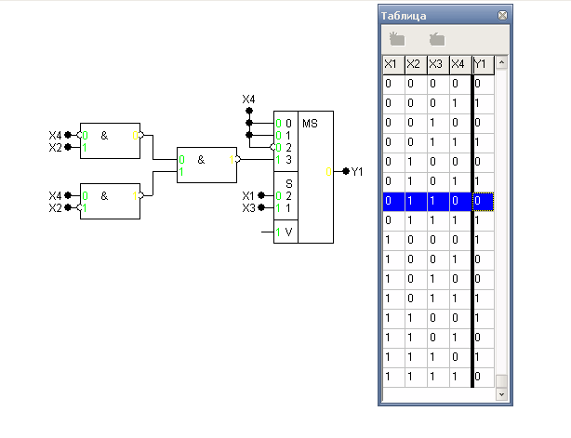  
N= $\left]\frac{3}{4}\right[*\frac{14}{14}+\left]\frac{1}{2}\right[*\frac{16}{14}=1+1.14=2.14$

**Розклад за :**



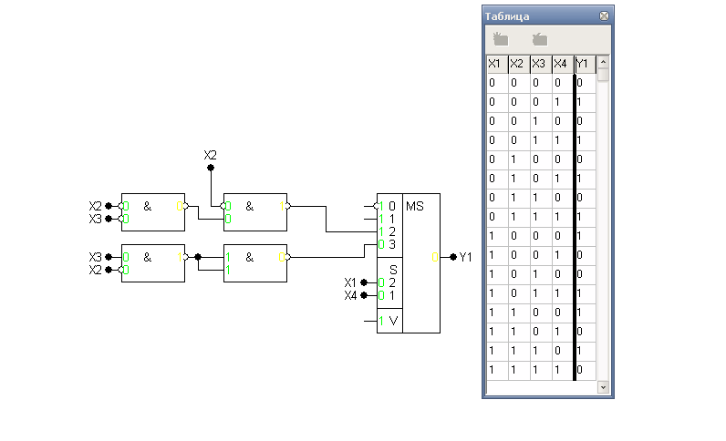

N= $\left]\frac{4}{4}\right[*\frac{14}{14}+\left]\frac{1}{2}\right[*\frac{16}{14}=1+1.14=2.14$

**Розклад за :**



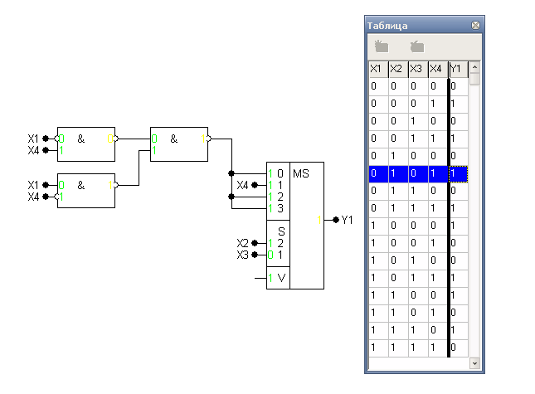

N= $\left]\frac{3}{4}\right[*\frac{14}{14}+\left]\frac{1}{2}\right[*\frac{16}{14}=1+1.14=2.14$

**Розклад за :**



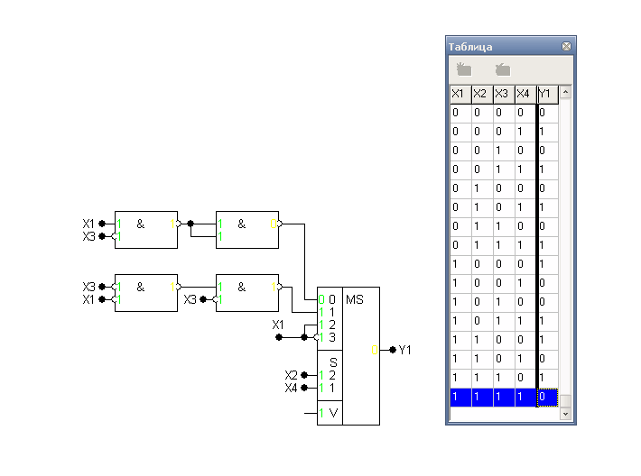

N= $\left]\frac{4}{4}\right[*\frac{14}{14}+\left]\frac{1}{2}\right[*\frac{16}{14}=1+1.14=2.14$

**Розклад за :**



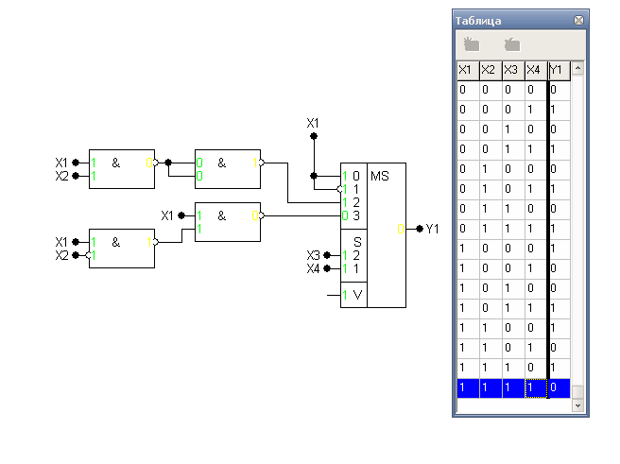

N= $\left]\frac{4}{4}\right[*\frac{14}{14}+\left]\frac{1}{2}\right[*\frac{16}{14}=1+1.14=2.14$

Складність схем за умовними корпусами є однаковою для всіх варіантів.

***Побудова системи на дешифраторі***

$Z1=5∪6∪7∪8∪9∪10∪11∪12=\overline{\overline{\overline{5 }\overline{6} \overline{7}} \& \overline{\overline{8} \overline{9} \overline{10}} \&\overline{\overline{11} \overline{12}}}$

$Z2=1∪2∪3∪4∪9∪10∪11∪12=\overline{\overline{\overline{1 }\overline{2} \overline{3}} \& \overline{\overline{4} \overline{9} \overline{10}} \&\overline{\overline{11} \overline{12}}}$

$Z3=0∪3∪4∪7∪8∪11∪12∪15=\overline{\overline{\overline{0 }\overline{3} \overline{4}} \& \overline{\overline{7} \overline{8} \overline{15}} \&\overline{\overline{11} \overline{12}}}$

$Z4=1∪2∪4∪7∪9∪10∪14=\overline{\overline{\overline{1 }\overline{2} \overline{4}} \& \overline{\overline{7} \overline{9} \overline{10}} \&\overline{\overline{14} }}$

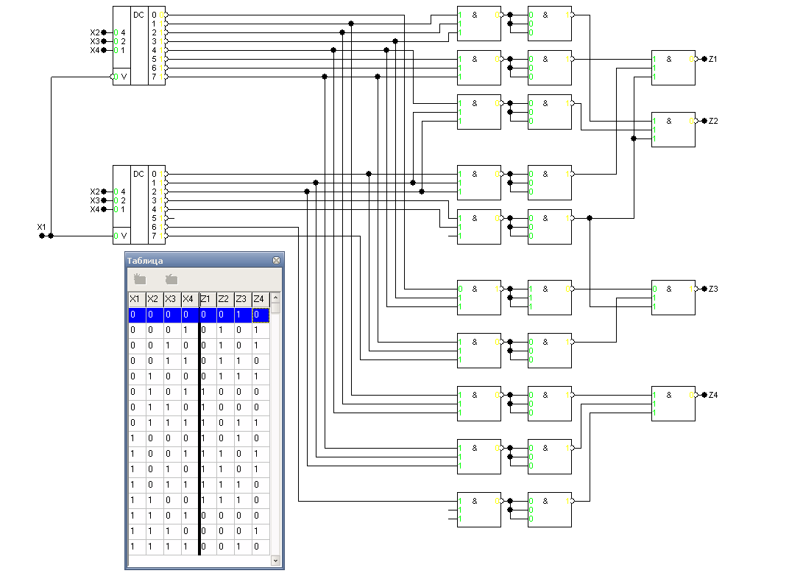

N= $\left]\frac{24}{3}\right[*\frac{14}{14}+\left]\frac{1}{1}\right[*\frac{24}{14}=8+1.7=9.7$